Project: Interactive polling process

This project deals with interactive polling, recording the votes and displaying the real time vote counts.

The working procedure is as mentioned below:

* Poll list takes you to the list of questions created. And Add question takes to page “/create” with form to create question.
* ***Add Question***: We can add questions here. Validation includes Question should not be empty and at least two Choices must be present. Then Add question enables.
* ***Add Choice:*** When Add choice is clicked dynamic input is created where you can add your option and even you can remove with side button.

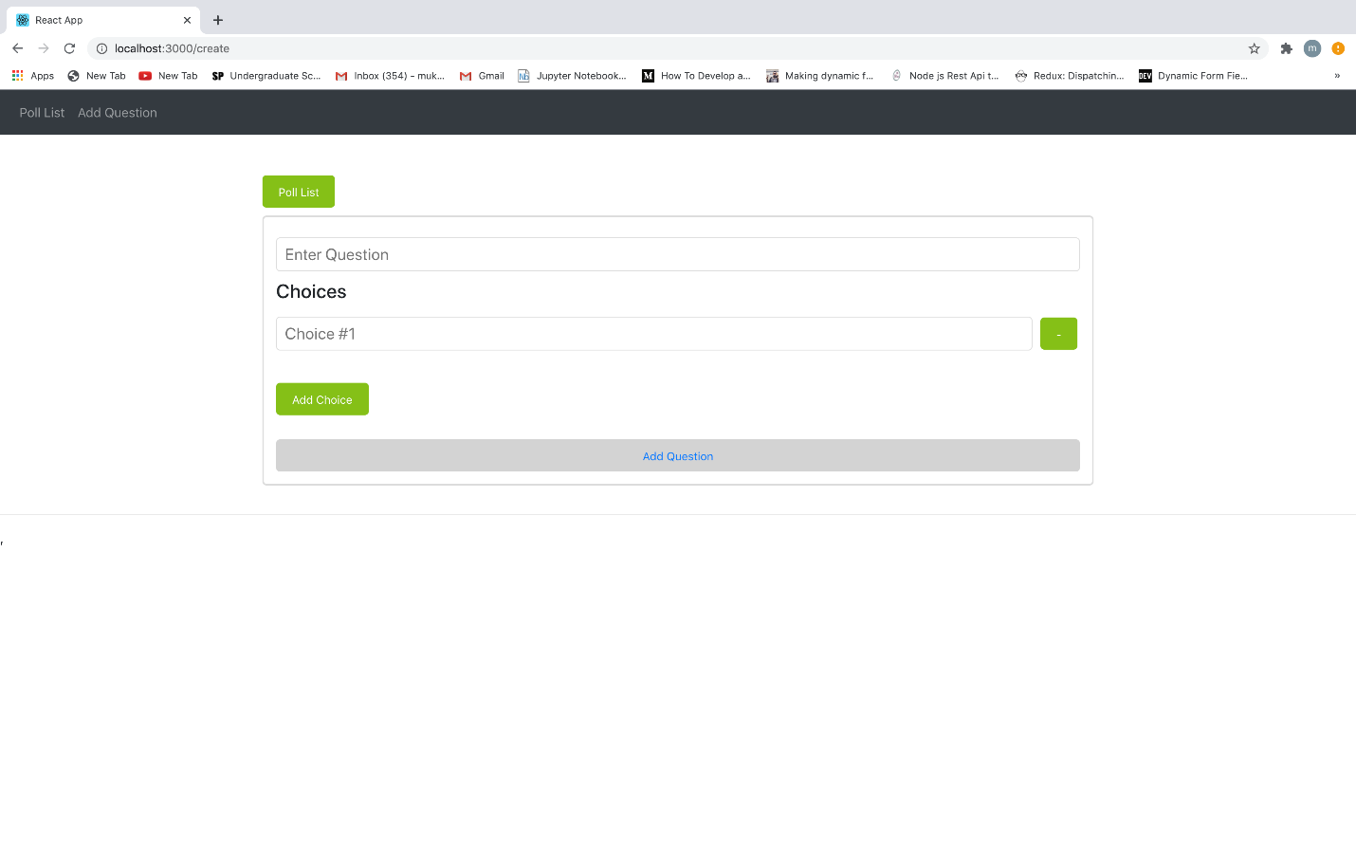

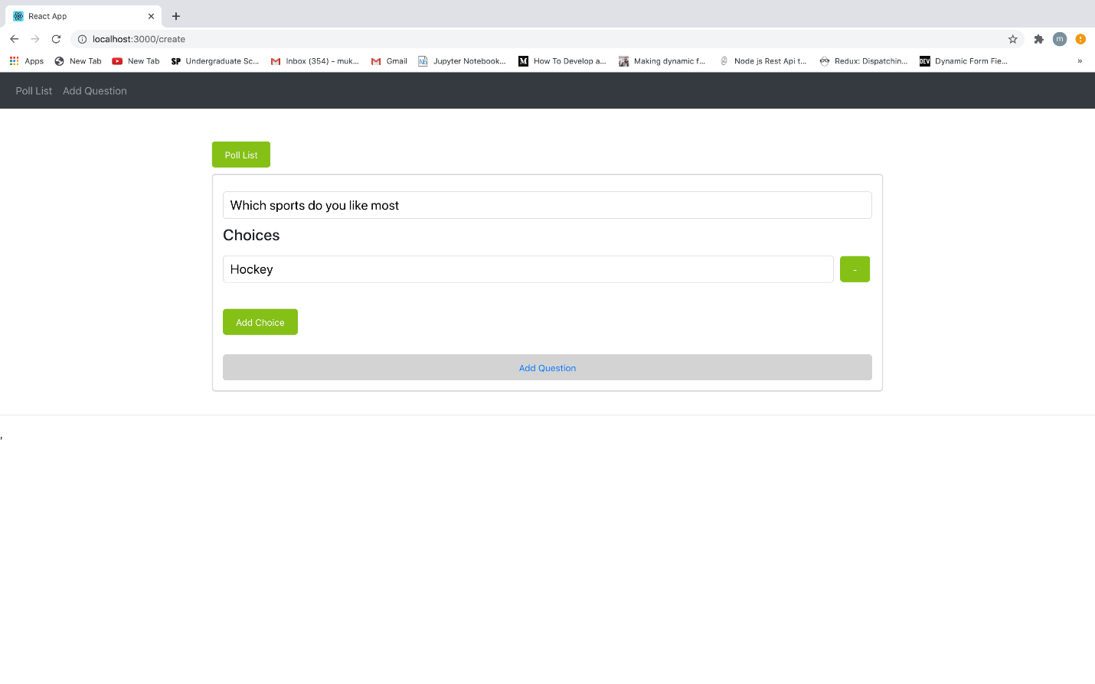 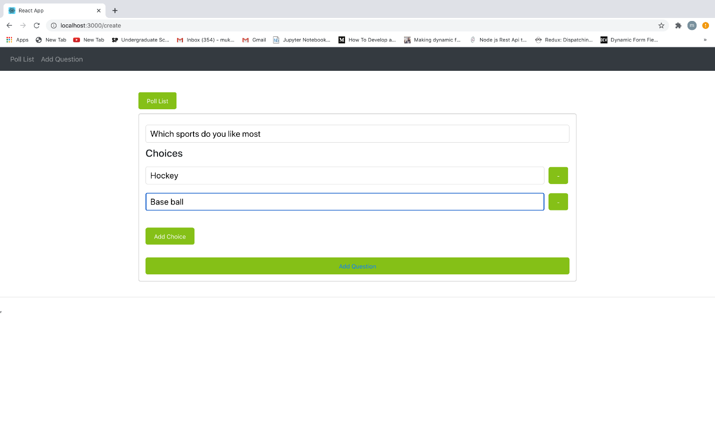

* When you navigate to page “/” displays list of questions created. The Question section has two buttons:

1. ***Open***: When this button is clicked a pop up box open which shows the choice to select. After selection of the option , a pop with all the choices which shows no. of votes and percentage of votes.
2. ***Close***: When close button is clicked it shows a pop up with all choices and number of votes. When close poll is clicked, voting will be closed. So, open and close buttons are disabled.

As Question has two statuses: Open and Close When Poll is closed status of the question is changed to ‘close’.

Below are some of screen shots which shows opening and closing of question.

